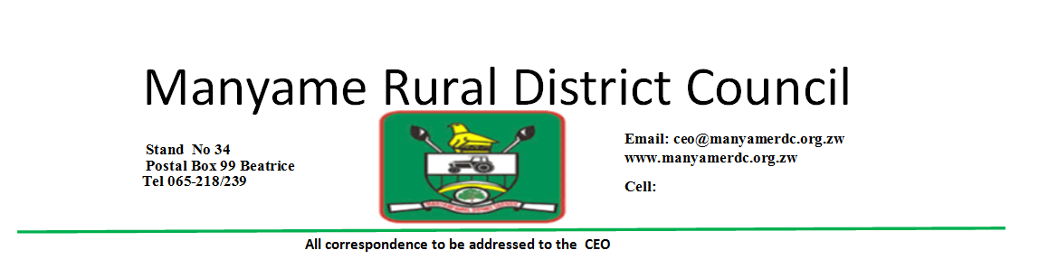

**TENDER INVITATION: LEASING OF GOMBE BEERHALL**

**Tender Number: FIN 10/2025**

Tenders are invited from interested parties for the leasing of Gombe Beerhall situated at Gombe Business Centre

Interested parties can obtain tender documents from Manyame Rural District Council between Monday and Friday from 0745hrs to 1645hrs upon payment of a non-refundable fee of US$50.00 excl vat.

Tenders must be enclosed in sealed envelopes and clearly endorsed on the outside with the advertised tender number.

**Tenders should be accompanied by the following**:

* Application letter
* Company registration and tax clearance certificates in the case of companies

Tender submissions should be posted or hand delivered to the following address by **0900 hours on** **03 June 2025**

**The Chief Executive Officer Manyame Rural District Council**

**Manyame Rural District Council OR Beatrice Head Office**

**P.O .Box 99 54km peg along Harare Masvingo Road**

**Beatrice**





**TENDER INVITATION: LEASING OF MARIRANGWE BEERHALL**

**Tender Number: FIN 11/2025**

Tenders are invited from interested parties for the leasing of Marirangwe Beerhall situated at Gombe Business Centre

Interested parties can obtain tender documents from Manyame Rural District Council between Monday and Friday from 0745hrs to 1645hrs upon payment of a non-refundable fee of US$50.00 excluding VAT.

Tenders must be enclosed in sealed envelopes and clearly endorsed on the outside with the advertised tender number.

**Tenders should be accompanied by the following**:

* Application letter
* Company registration and tax clearance certificates in the case of companies

Tender submissions should be posted or hand delivered to the following address by **0900 hours on** **03 June 2025**

**The Chief Executive Officer Manyame Rural District Council**

**Manyame Rural District Council OR Beatrice Head Office**

**P.O .Box 99 54km along peg Harare Masvingo Road**

**Beatrice**

